Govt. Digvijay College Rajnandgaon
Department of Geography
Session 2024-25

S. No. | Date | Name of Activity | No of Participants
01. | 16-5-2024 | Board of Study | 01-Alumani- Shri T. K. Verma
02. | 20-5-2024 | Ph.D. 6 Monthly Report Preesentation | 06 Research Scholars
03. | 24-6-2024 | RAC in Geography | 02 candidates  under the supervision of  Dr. Nivedita A. Lall
04. | 28-6-2024 | Notice for MA III & BA III semesters class  From 01-07-2024
04. | 03-7-2024 | Tree Plantation | MA III 5
05.
06.
04.
05.
06.
07.
08.
09.
10.
11.

1. Board of Study
Board of study in Geography was organized on 16-5-2024 as per the instruction of the Principal. The participants were as follows:-
Chairperson – Dr. Krishna Nandan Prasad
Member- University Nominee – Dr. Shushma Yadav
Member - College Nominee – Dr. S. K. Das
Member - College Nominee - Dr. K. K. Dwivedi
Member – Dept Teaching Staff – Dr. Suvendra Jenamani
Member – Dept Teaching Staff – Dr. Shraddha Sahu
Member – Dept Teaching Staff – Shri Hemraj Daura
Member Student Alumni – Shri Tikeshwar Kumar Verma
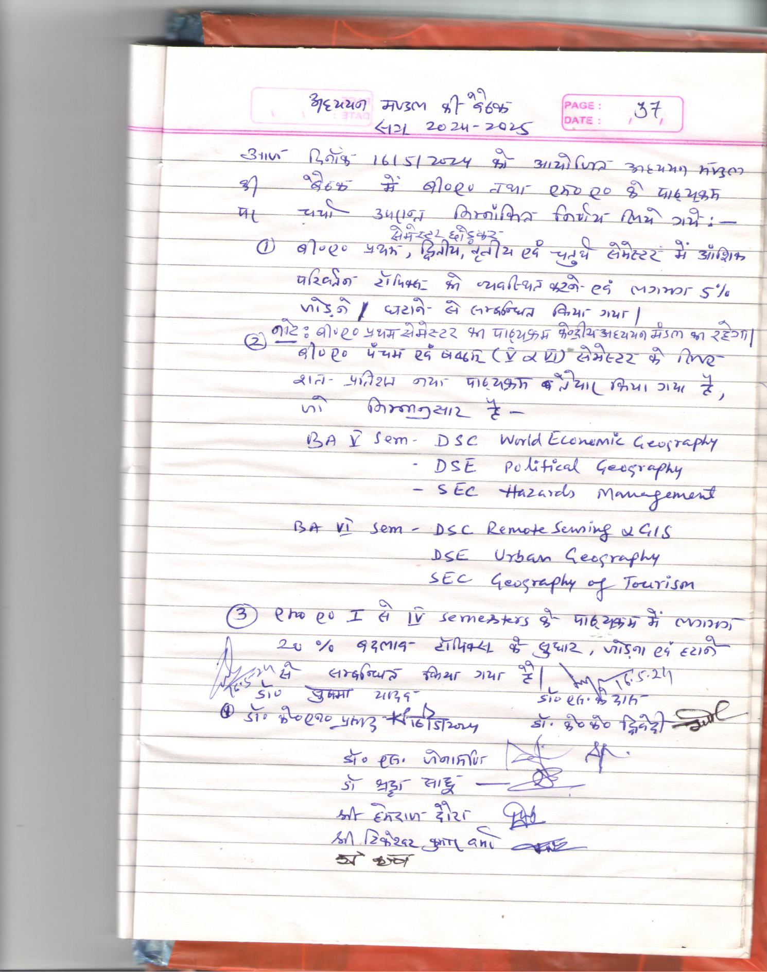

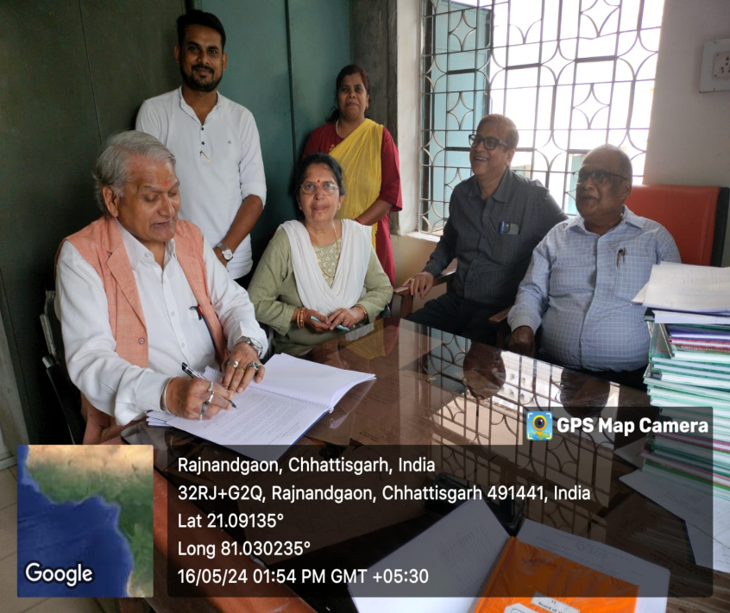

2. 6 Monthly Progress Report PPT Presentation
6 Research Scholars in Geography presented their 6 monthly progress report using PPT in the presence of the Head of the Department, Dr. K. N. Prasad on 20-5-2024. They were as follows. Their detailed presentation has been given below.
- Shri T. K. Verma
- Shri Jhamman Lal
- Ranita Dawn
- Vinita Kashyap
- Bhavna
- Lekha
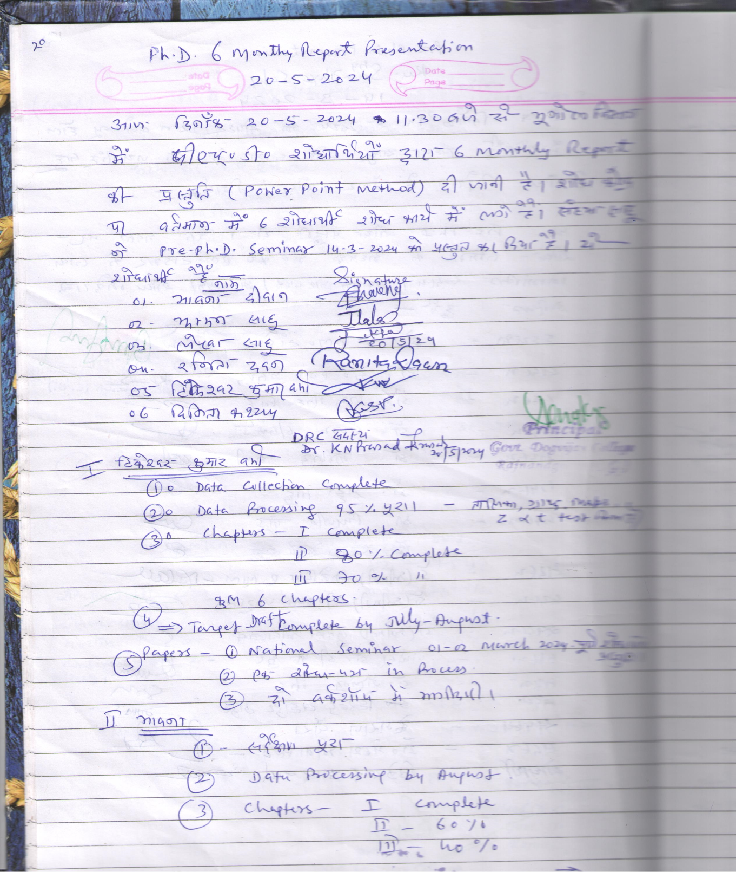

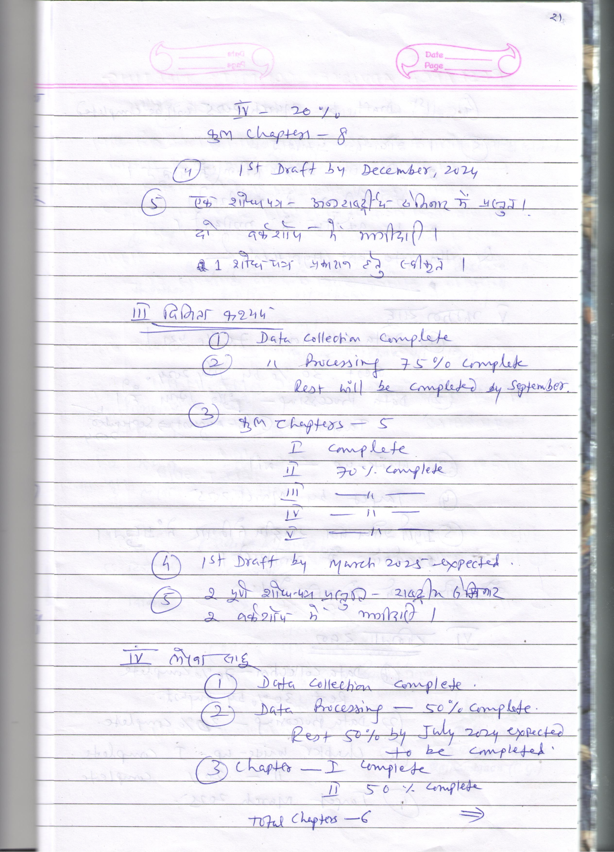

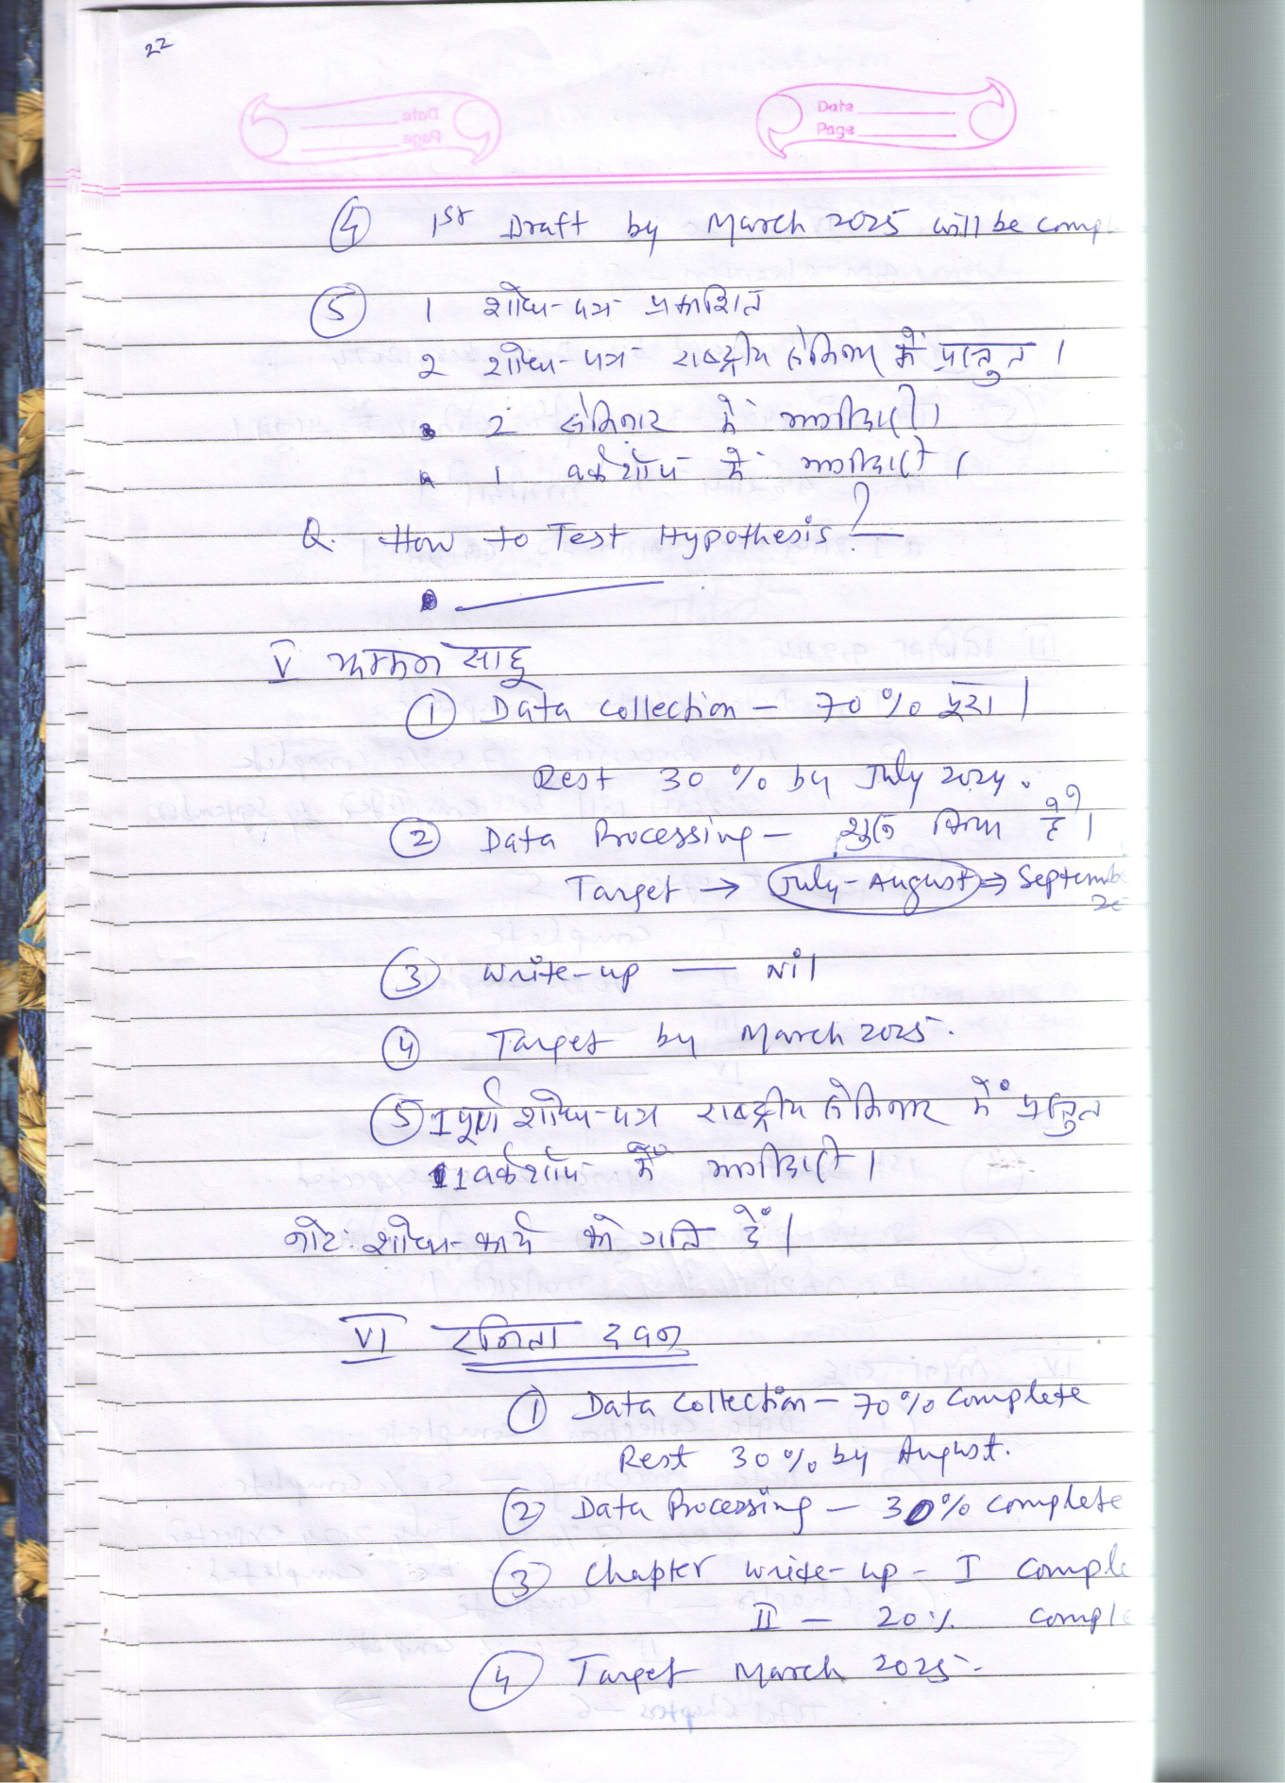

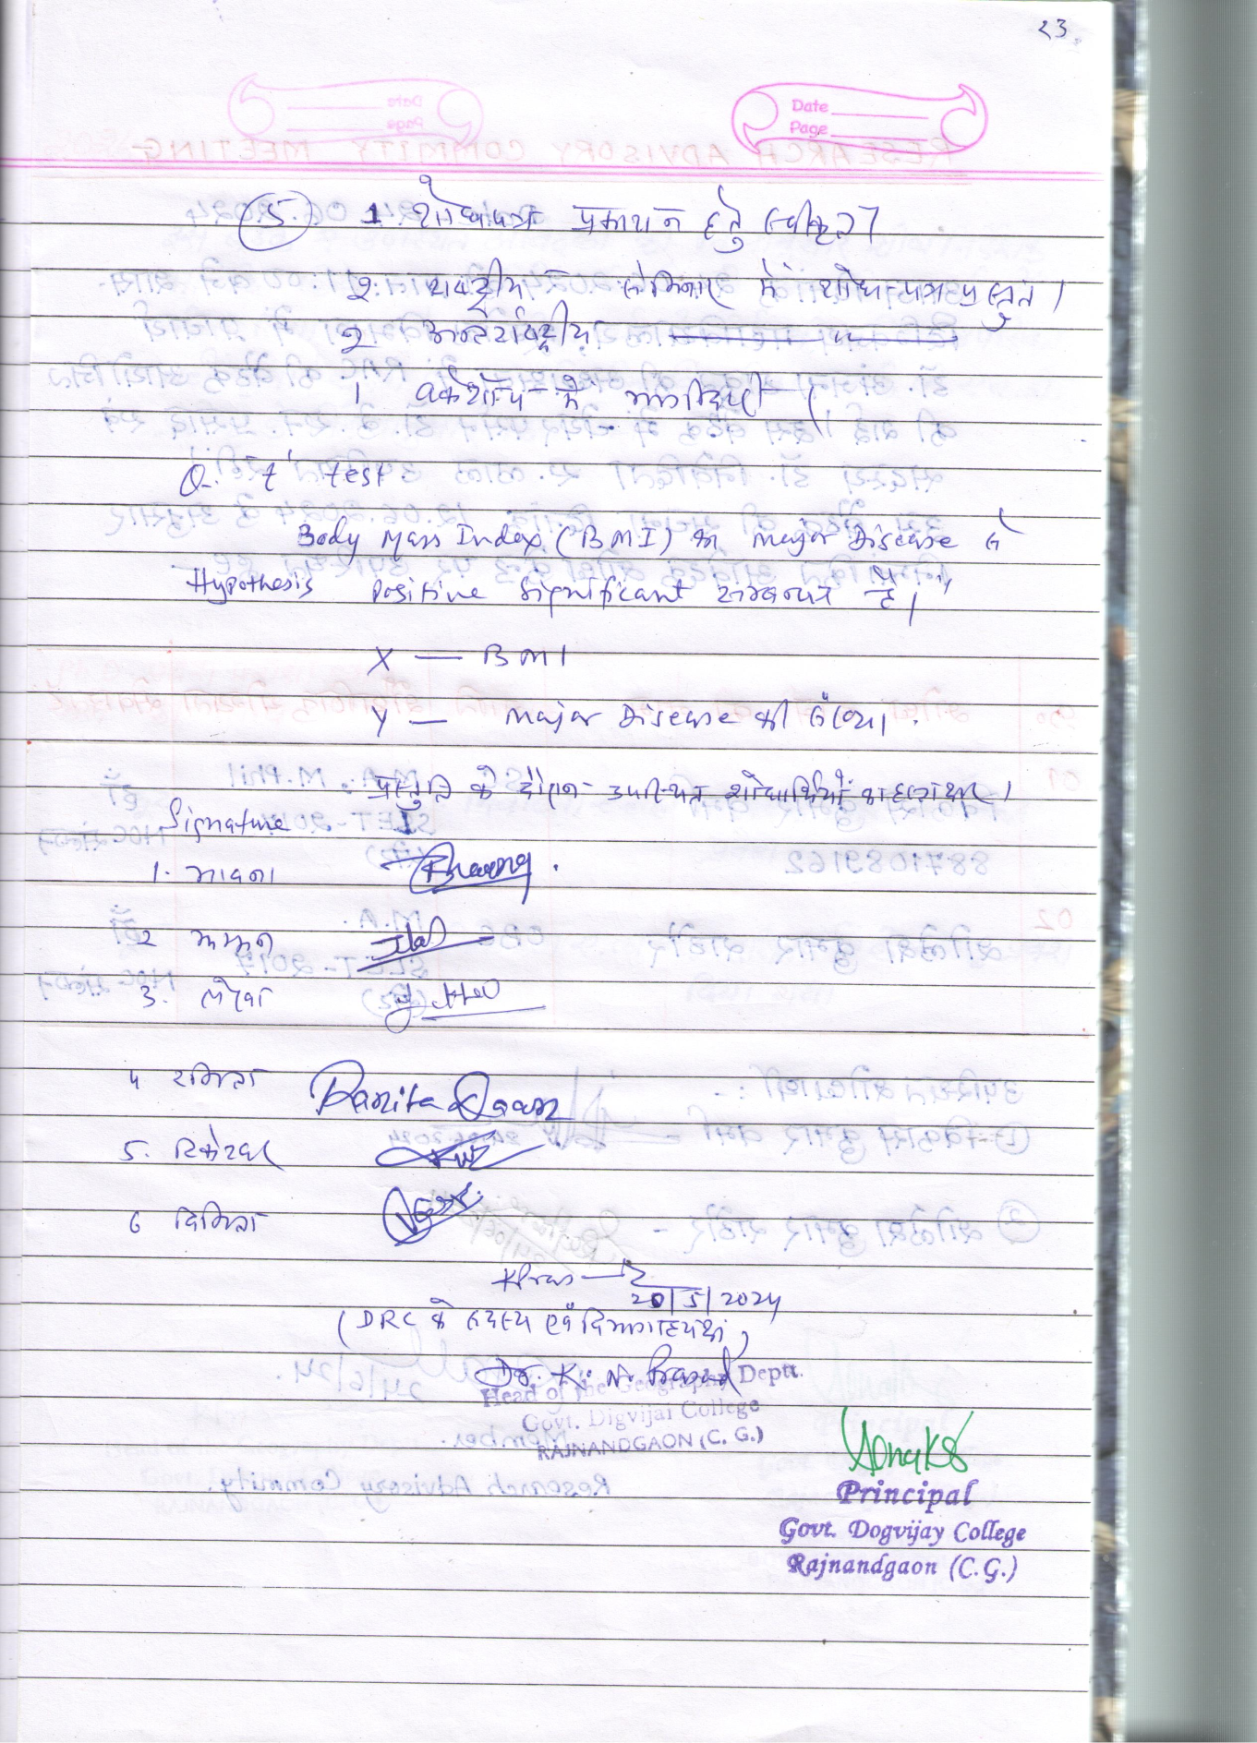
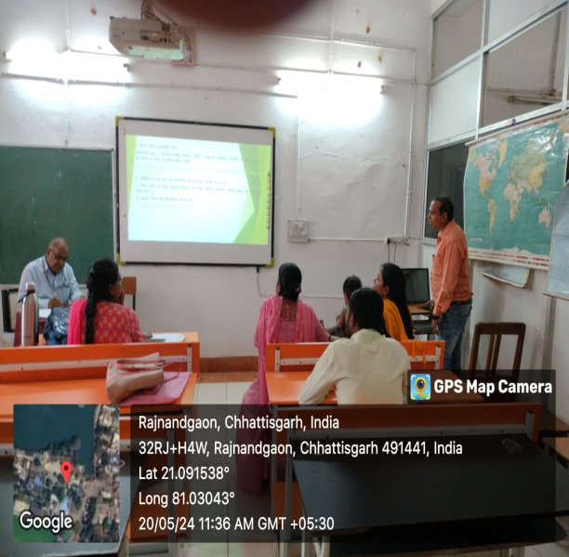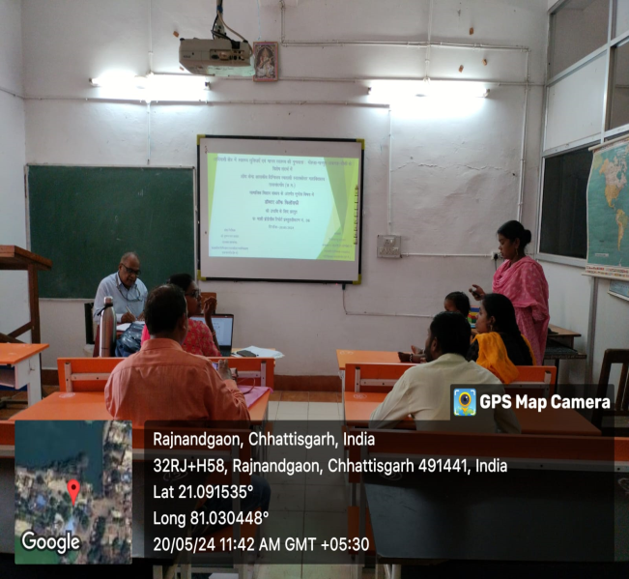

- RAC in Geography
Research Centre , Govt. Digvijay Autonomous PG College Rajnandgaon (CG) was organized on 24-6-2024 from 11 am.
Shri Vikar Kumar Verma and Shri Shoulesh Kumar Rathod were allotted guide after their documents verification. They will pursue their research work under the supervision of Dr. Smt Nivedita A. Lall.
Shri Shoulesh Kumar Rathod has to do 6 month course work, as he has done MA only. The course work will start from 1st week of July at this Research Centre preferably between 4 to 5 pm.from 4-7-2024.

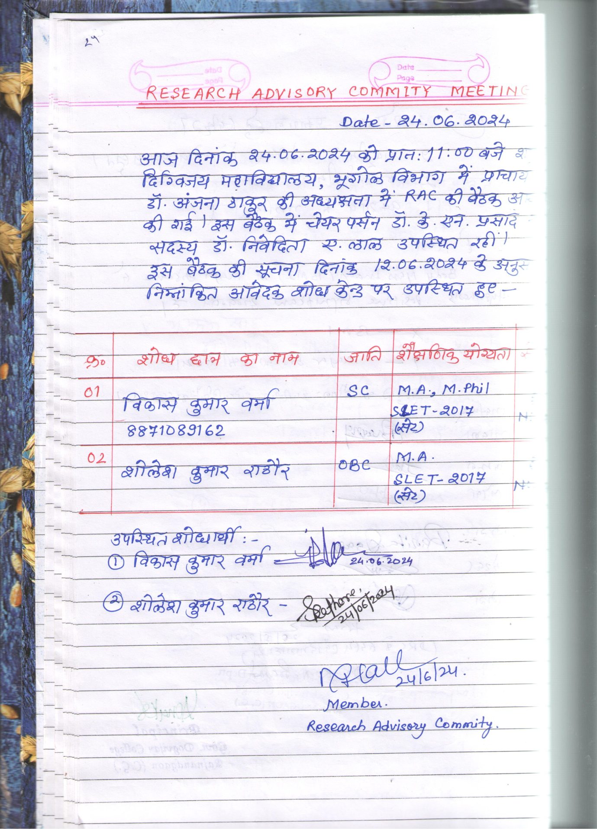

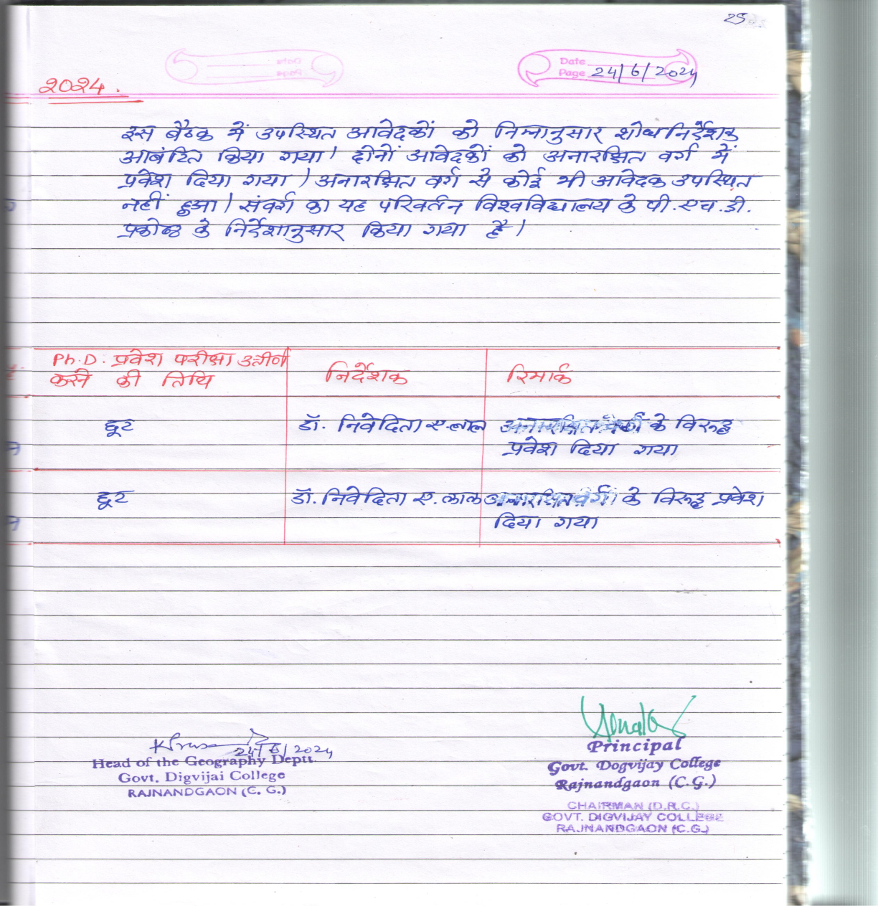
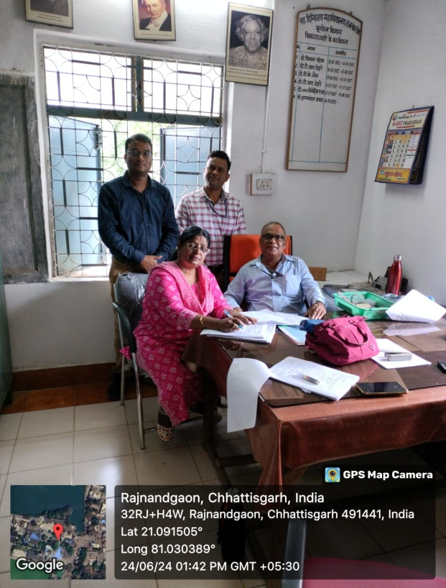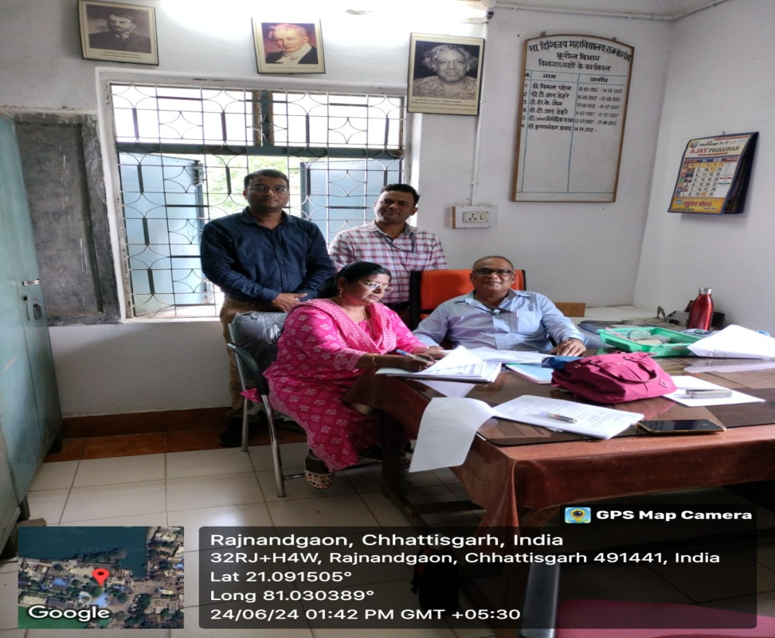

- Notice for the Beginning of MA III & BA III semesters Classes
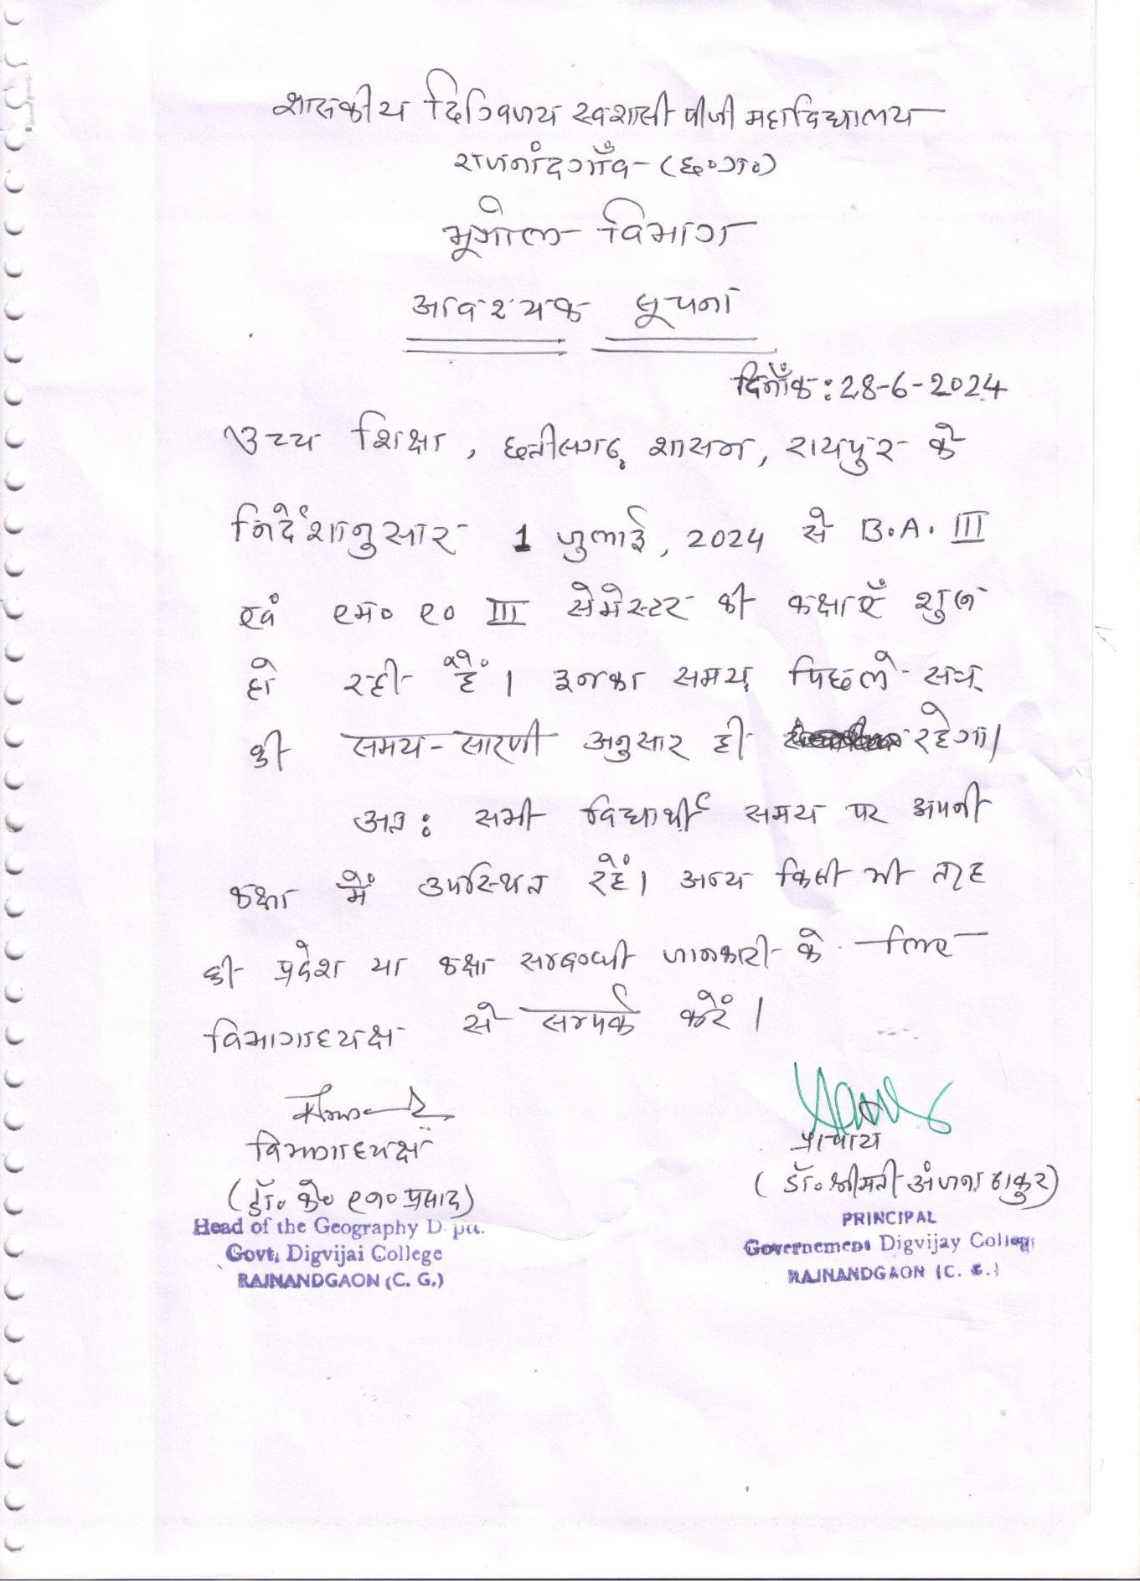

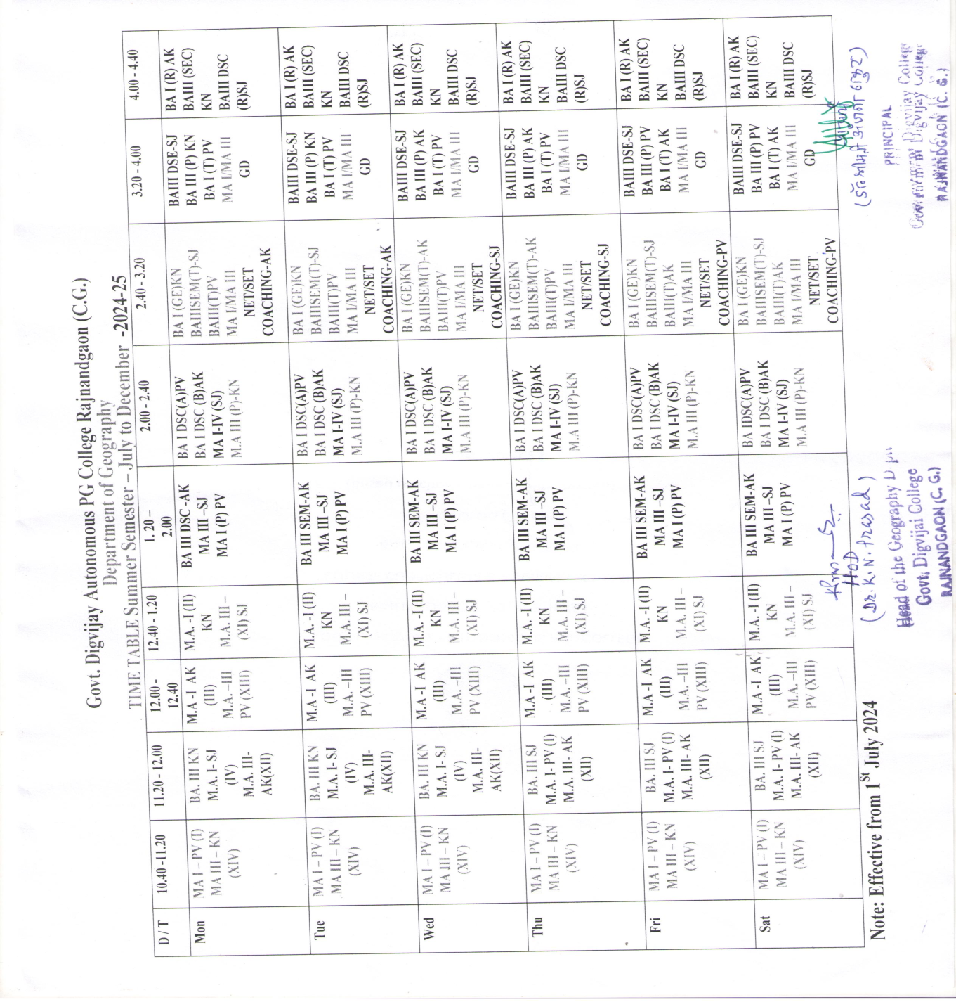

- Tree Plantation in the Campus
As per the instruction of the Principal Dr. Smt. Anjana Thatur, Department of Geography participated in Tree Plantation with the sole purpose of making the college campus – A Green Campus.
Dr. Krishna Nandan Prasad, HoD, Shri T. K. Verma, Research Scholar, Shri Kishore Banjare, Lab Technician and MA III semester students participated in this noble endeavour.
